Healthy and sustainable ‘Out of home’ Food offer in County Durham

The North East Good food for all pilot and the Global sustainability Index provide opportunities to highlight the excellent work happening in County Durham and as these involve comparison tools, enable us to learn from best practice regionally, nationally and globally. The healthy weight review 2023 identifies where we need to focus in the county to increase healthy weight levels. In the ADPH healthy weight statement 2023 key messages call for food standards in all settings and a whole systems approach to create an environment that promotes good health and enables healthy eating and positive attitudes to food. Implementing and embedding ‘Out of home’ provision standards can make a significant contribution to reducing the obesogenic environment and working towards climate change emergency response plan and sustainable healthy places silver goals.
The literature demonstrates there are likely to be population benefits to having a consistent approach to improving the ‘out of home’ food off in County Durham. Taking a county wide systematic approach to ‘out of home’ food offer can support DCC Health and Wellbeing Board aims to increase healthy weight levels. Having one award system will help tackle the obesogenic environment, improve healthy and sustainable food options and increase nutrition status for our residents which can benefit mental health, healthy weight and healthy development and ageing.
This report aims to provide the evidence of barriers, facilitators and what works including best practice in other areas.

Utilising the knowledge base of what works and systems thinking there is great potential to embed an award which could be implemented and embedded across settings and sectors.
Why would we want to do this?
- Improved nutrition status across the life course supporting healthy development, growth, immunity, mental health and overall health status as we age
- Prevention programme – longer healthier lived years (DCC and NENC ICS - to keep people healthier for longer)
- Healthy weight – increase opportunities for residents to consume healthy options/replace with HFSS, which will support healthy weight levels
- Consistency in schools and early years settings – a structured and simplified approach to healthy food provision
- Opportunity for consistency in all settings and programmes - fun and food programme, food inequality initiatives, foster care, children’s and adult social care, Hospital, Leisure, workplace
- A process which allows the DCC health and sustainability policy to be actioned easily – removing barriers (thus far food focused strategies, charters and policies have been developed and lost impetus quickly)
- Supporting a community food focus

Tackling the obesogenic environment
Achieving the energy balance of intake of calories and physical activity to maintain a healthy weight is the key. Our food environment is a major barrier. The ‘norm’ of less healthy choices being the default makes it very difficult for people to eat healthily. Prior to the pandemic, the rise of eating ‘out of home’ from takeaways and food outlets was shown to be a contributor to increased weight across the UK. Meals eaten ‘out of home’ or from takeaways tend to be much higher in fat, sugar and salt (HFSS) and lower in important micronutrients than food cooked in the home. A higher quantity of fast food outlets in more deprived areas have been reported (PHE, 2017).
County Durham fast food density map How does this map against childhood obesity
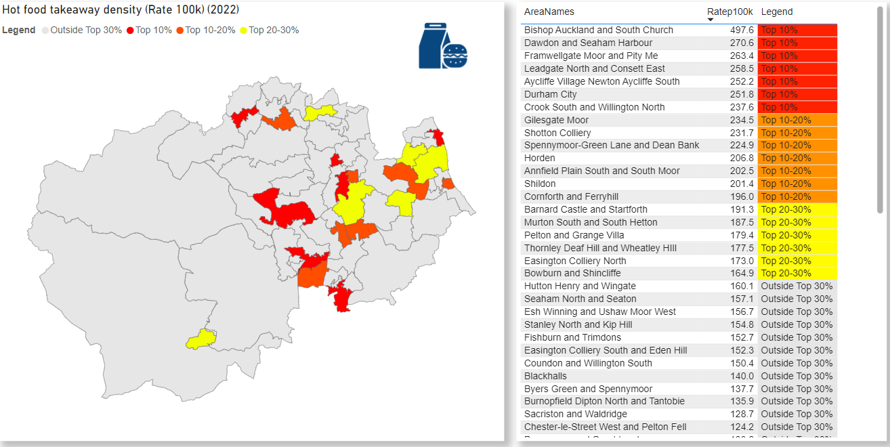
InstantAtlas Durham – Health & Wellbeing – Healthy Weight (durhaminsight.info)

County Durham HOT pilot
In February 2023 the findings of the ‘Healthy Options Takeaway’ (HOT) pilot evaluation were presented and reported to DCC PHSMT.
The findings suggested participating businesses valued the course content and were able to apply healthy eating principles in practice, however, the face-to-face delivery posed challenge in sustaining/embedding this model across the county. Issues were revealed in engaging business due to the time out of their day, the capacity of staff to deliver and cost of material.
Post evaluation The HOT steering group (DCC catering, PH, CC, CP, Academics, local business and food initiative staff) were in agreement that a more sustainable model was required and that rather than sole focus on takeaways, there would be more value in an award which encompasses all settings.

County Durham partners
The Food Durham Advisory group (FDAG)was re-established in Summer 2023, with a Food partnership coordinator leading a review of the County Durham food strategy aiming to achieve the Silver sustainable food award, and the funded cooking, growing and skills across 14 schools. The Good Food for All North East pilot and the Global Sustainability Index (Visit Durham) will shine a spotlight and compare against other areas on how well we are tackling the obesogenic environment and sustainable food (Healthy weight review recommendations including FFT policy review, healthier advertising policy, food security recommendations). The
Coproducing simple standards for a range of settings and using learning from PHE toolkit and evidence (Appendix A) can overtime shift to a whole systems approach to healthier and sustainable food offer across County Durham.
Healthy weight review identified leverage opportunities, partners and workstreams (Healthy Weight alliance members):
- Family hubs
- Poverty action strategy group DCC (PASG)
- NHS – Primary care colleagues, GP practices, local settings, commissioning and NENC healthy weight team
- Regional healthy weight network – OHID and ADPH
- Climate change (CERP) team
- Early years framework – DCC Public health Starting well, healthy settings team, Education, childminders and early years settings
- Health and wellbeing framework and school food contract team – DCC Public health and Joanne Murphy team (school food safety and food standards)
- New College academy trust 11 schools – Head of facilities
- Young people secure unit NA
- Adult and child social care teams – settings and outreach (LAC process and social worker training)
- Business and workplace (BHAWA, Business Durham, Climate change team business and Food inequality and waste partnerships )

Mapping and addressing the barriers to healthy food provision in County Durham
COM – B diagnosis – mapping the barriers and behaviour change techniques for healthier out of home food provision
COM-B Component |  | Identified barriers to healthy eating | Intervention functions | BCT
Opportunity | Physical | Access to healthy food/drink options ‘out of home’.  Access to healthy options in places where children meet.  Having the time – convenient healthy options available | environmental restructuring | Adapting menus, adding nudges – healthy food cues to the menus and shelving
Opportunity | Social | Familial/peer habits and attitudes to healthy eating  Community/peer norms  Advertising of HFSS  Families purchasing unhealthy foods | Restriction, environmental restructuring, modelling, enablement | Nudges, menu adaptations – making easier to choose healthy options
Motivation | Reflective | Low awareness/belief of importance of HE  Belief that healthy foods taste bad/boring.  Beliefs around financial costs of healthy foods and the level of rewards to HE. | Education, persuasion, incentivisation, | Information to positive health benefits, offers on healthy options, adapted menus and reduced portions of tasty dishes
 | Automatic | Established eating habits | Incentivisation, environmental restructuring, enablement | Improve healthiness of existing options e.g. cooking/preparation methods and smaller portions

There is limited evidence of a whole systems approach to a healthy and sustainable food offer, and suggested barriers to the success of healthy catering schemes are variations in criteria, branding and names across settings and place which can cause confusion for outlets and consumers. Healthy catering food outlet schemes in local authorities are generally led by environmental health or trading standards due to their relationship with local business and tend to focus on encouraging outlets to switch to healthier ingredients, menus and cooking practices. They focus mostly on behavioural economics, seeking to nudge consumers in the direction of making healthier choices through, for example, encouraging the sale of food in smaller containers or the placing of healthier drinks at eye level.

Barriers to healthier ‘out of home food’
Understanding the barriers to a healthy food/drink offering in County Durham is critical to successfully shifting towards ‘healthy choices being the normal choice’. For example, smaller food outlets struggle to be profitable, and multiple factors can make change difficult. The following have been revealed as perceived or real barriers to ‘out of home’ healthier options:
- lack of space and the right equipment, or skills and resources to prepare or cook healthier options
- a fear that fresh fruit and vegetables would be wasted and lose the outlets money
- the higher cost of healthier options. (some suppliers charge more for healthier products and additional costs cannot be passed on to the customer)
- the lack of availability of healthier options in appropriate sizes for small outlets, that may only need small quantities
- a fear that some changes, such as reducing salt, would affect the taste and deter customers
- a reluctance to change popular recipes or traditional ethnic cuisines
- lack of external support for a business to offer healthier food and drink

PHE toolkit recommendations
- Local practice examples suggest food outlets more likely to make small changes to menus/catering practices when they can see business benefits
- Outlets can use a range of ‘nudge’ strategies to influence consumers to make healthier choices (for example, using lower fat milk in hot beverages unless people specify otherwise). However, the effectiveness of these strategies appear to be context specific.
- Working with local partners such as schools, the community and the supply chain (as part of a whole systems approach) is most likely to encourage change.

Healthier catering scheme key points:
- healthier catering schemes are designed to encourage outlets to switch to healthier ingredients, products, menus and cooking practices
- outlets are more likely to engage in a healthier catering scheme if it offers clear business benefits, requires minimal effort, and can be introduced without deterring customers
- evaluations of healthier catering initiatives have tended to focus on take-up by outlets, rather than their impact on health

Strategies for Encouraging Healthier ‘Out of Home’ Food Provision: A toolkit for local councils working with small food businesses
The toolkit allows an area to map and classify types of food outlets (34 types), a summary of the advantages and disadvantages of different approaches is shown below (Bagwell, 2015; PHE, 2017)
Approach: Advantages Disadvantages:
Generic – targeting a wide variety of food outlets. For example, Eat Out Eat Well
- Allows all outlets to participate and may lead to a greater public awareness
- Criteria of some awards may be too challenging for the least healthy outlets, such as takeaways with limited menus, to achieve
- Requires capacity within the local council to regularly monitor
Specialist – targeting particular types of outlets or issues. For example, Healthier Takeaways project in Antrim – targeted at fish and chip shops, and The Heartbeat award scheme for nurseries
- Schemes tend to be tailored to the outlet type/issue and thus likely to be more successful
- Better at targeting least healthy outlets
- Requires more intensive work with outlets
- Reaches fewer outlets thus generates lower public awareness
Award – single or multitiered. For example, Eat Out Eat Well (3 tiered award scheme), and Healthier Catering Commitment (single tier award scheme)
- May encourage greater participation by outlets and increases public recognition
- Unsuitable for outlets/areas where a health by stealth approach may be more effective
- Tiered awards may deter outlets only likely to reach a bronze level
- Single tier schemes don’t differentiate between those with differing levels of healthier food and drinks offers
Non-award. For example, Truckers Tucker
- Better suited to the least healthy types of outlets that are unlikely to gain awards
- May not provide sufficient motivation for some outlets Targeted at specific geographical areas or communities. For example, initiatives targeted at outlets around schools.
- Peer group pressure from neighbouring outlets more likely
- Easier to link to other local initiatives targeting obesity
- Impact restricted to area targeted

Encouraging healthier takeaways in low-income communities toolkit – see toolkit and case studies

Scoping of best practice in other areas of the UK
Good practice shows there is scope to embed a system to improve healthy eating across settings.
Many areas have their own local authority voluntary award scheme and some areas commission Food for life, soil association to tailor an award to the area needs. Some detail of practice in other areas are shown below.
Joining up health agendas is a good way to provide consistency and simplify County Durham’s approach, one of the best ways identified is the Norwich business merit scheme; The Healthier Options Norfolk award (HONOR), including merits in achieving breast feeding friendly, disability access, locally sourced ingredients, best bar none (national home office licensed premises award), dementia awareness and healthy options.

Bristol City Council ‘Eating Better’ award
Bristol is a GOLD sustainable city and launched the ‘Bristol Eating Better’ Business and CYP (schools and EY provision) awards in 2017, post pilot. This is a healthy eating and sustainable food award.
There is gold, silver and bronze levels and all council food providers must have the gold award.
The award steering group includes colleagues from Environmental health, Procurement team, business and market trader reps (Market Ts must have Bronze award), and an existing Good Food 2030 partnership plan working group meet regularly.
The evaluation report conducted and produced by the University of Bristol provides the findings and how Bristol adapted the award scheme to better support and engage more businesses.
The how
2 public health staff members lead the scheme in Bristol – one for business eating better award and one for children and young people eating better award (schools, children settings and EY provision).
Process:
- Business applies online Bristol Eating Better Award
- Public Health do a check of business website, menus, social media and go over form – full check takes 1 hour
- Business engagement officers audit 10% of the businesses who have achieved the award annually – trained by PH lead
- EHO promote and identify businesses – provide a pack and postcard
- The award scheme is linked to Bristol city plan and linked with Food equality strategy

What can we take from this to address County Durham’s barriers to healthier out of home food?
- DCC providers must meet food award standards
- Steering group partnership established
- A comprehensive and easy to complete award application (including food waste and sustainability focus)
- An award scheme linked into the CD plan (reviewed in 2024-25) and County Food strategy incl. Food security
- BHAWA process
- Case study learning from the evaluation report

Middlesbrough, Redcar and Cleveland ‘Eat well’ award
This award scheme is focused on schools and early years settings including childminders. The award was developed due to a huge reduction of uptake in school meals and accompanied working with communities, children, and parents. Improving school menus as non-compliant, supporting schools with menu development. Public health has dedicated team (3 staff across South Tees) who have developed and coordinate the ‘Eat well award’. Bronze, silver and gold includes food waste, food education, oral health, leadership (based around WSA).
Have developed training for catering staff on public health e-learning hub and deliver some face-to-face training which schools prefer. They have an assessment tool as a spreadsheet checklist to ensure adhering to SFS.

Darlington catering awards: Healthy families and Healthy early years (HEY) awards
The healthy families award scheme is for all setting who provide a children’s menu, with a separate healthy early years award for EY settings and childminders. This scheme incorporates healthy and sustainable food elements. See checklists in appendices documents – healthy food policy templates for EY settings were provided.
These awards were coproduced with a range of partners including food businesses, environmental health, PH, education and speech and language partners, early years settings and childminders.
Darlington School food Qualification pilot – training of catering staff in schools – supported healthy changes in school, empowering catering staff and managers to make decisions to support children health, awareness of social importance of dining room and staff attitudes and nutritionally balanced meals and snacks including innovative approach to displaying and serving healthy foods.

Food for life Soil association

Working with various LAs across the UK, to embed a good food culture in schools’, early years, community hubs and wider. Tailored to local areas, either focused on schools or as part of whole systems approach in all settings. Leicestershire wider focus, Sheffield school settings and West Northamptonshire focused in schools and settings in areas of high levels of childhood obesity and deprivation.
The core ethos of healthy and sustainable food for all, FfL build a flexible, bespoke programme of support in an area – to target particular settings or receive support in meeting county-wide health and diet goals.

In Summary

Taking a county wide systematic approach to ‘out of home’ food offer will support DCC Health and Wellbeing Board aims to increase healthy weight levels. Having one award system will help tackle the obesogenic environment, improve healthy and sustainable food options and increase nutrition status for our residents which will benefit mental health, healthy weight and healthy development and ageing.

Investigate
Choosing to go it alone vs Food for life
Cost
Capacity
What do we have already in place?

Appendices documents

Contacts and links to evaluation and impact reports

Bristol
Rewarding food businesses that promote healthier and sustainable eating: Lessons learned from the Bristol Eating Better Award evaluation | PolicyBristol | University of Bristol
David Hudgell
Bristol Eating Better Award Co-ordinator
bristoleatingbetter@bristol.gov.uk
Caoimhe.govran@bristol.gov.uk CYP award coordinator

South Tees
Karen Pearson karen.pearson@redcar-cleveland.gov.uk
Anne Rose Anne_Rose@middlesbrough.gov.uk
Annabel Rams

Food for life Soil association awards and working with
ffl_sheffieldreport_final.pdf (foodforlife.org.uk)
National framework local partnerships - Food for Life
Food for Life Served Here - Food for Life

Darlington healthy families checklist for business
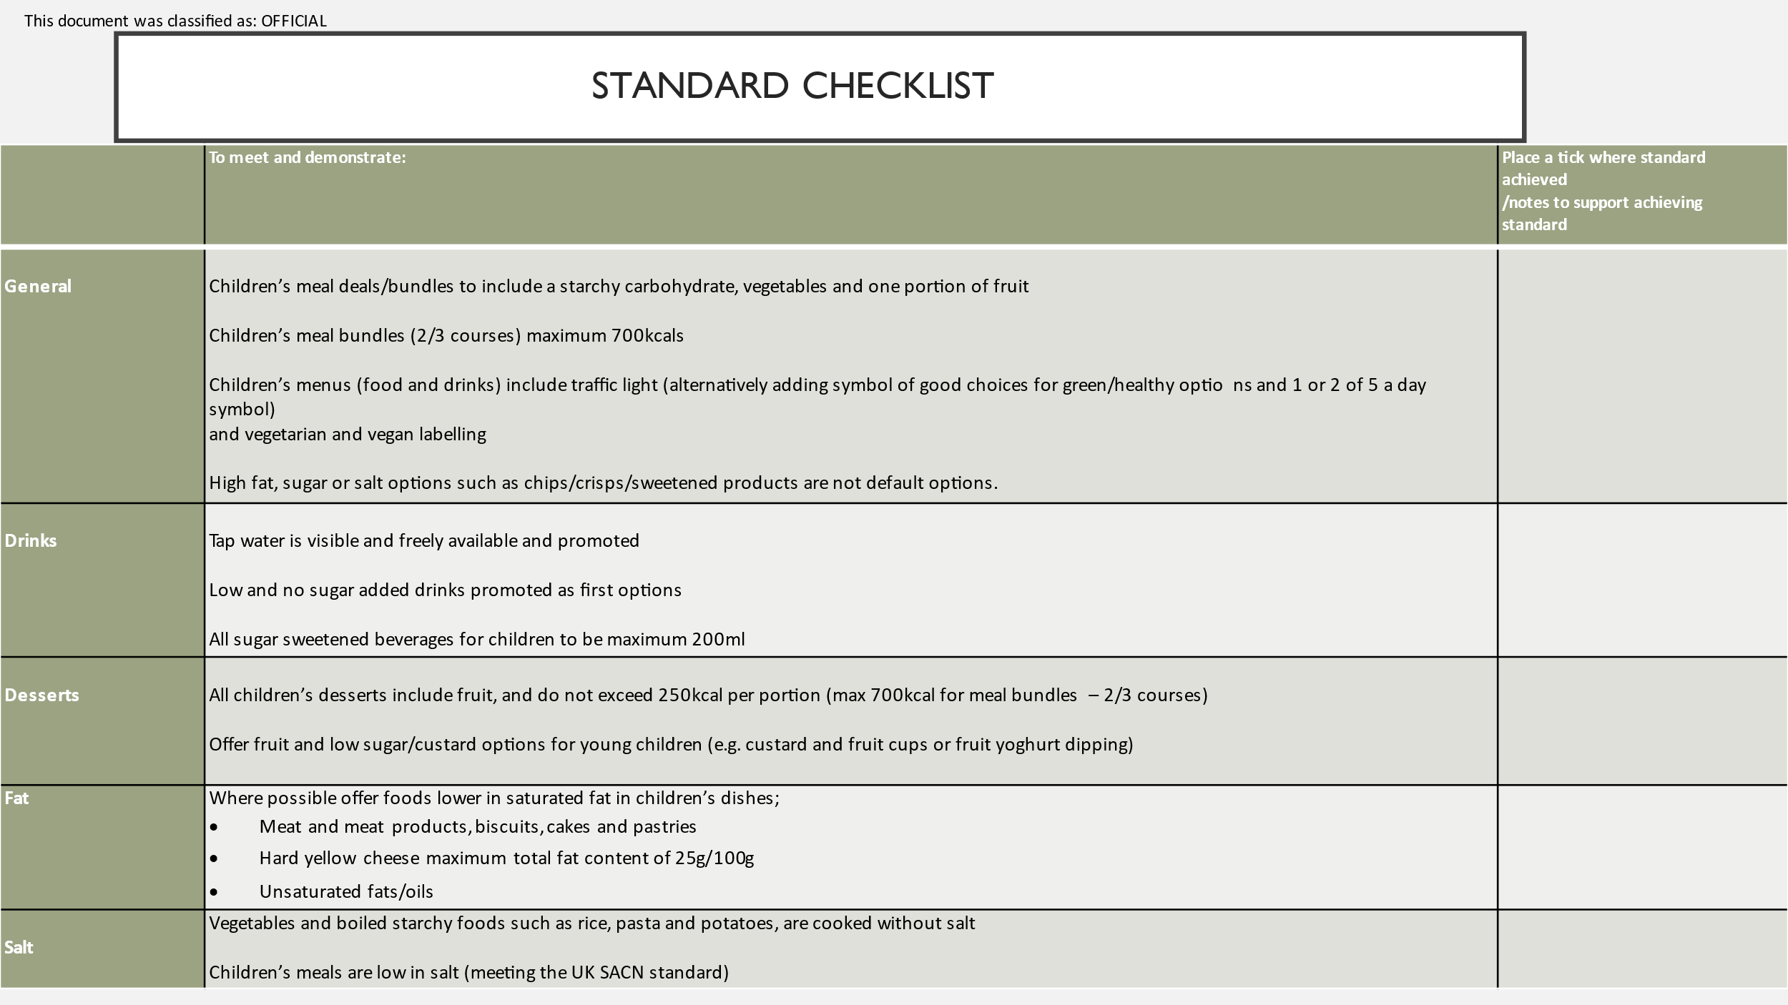
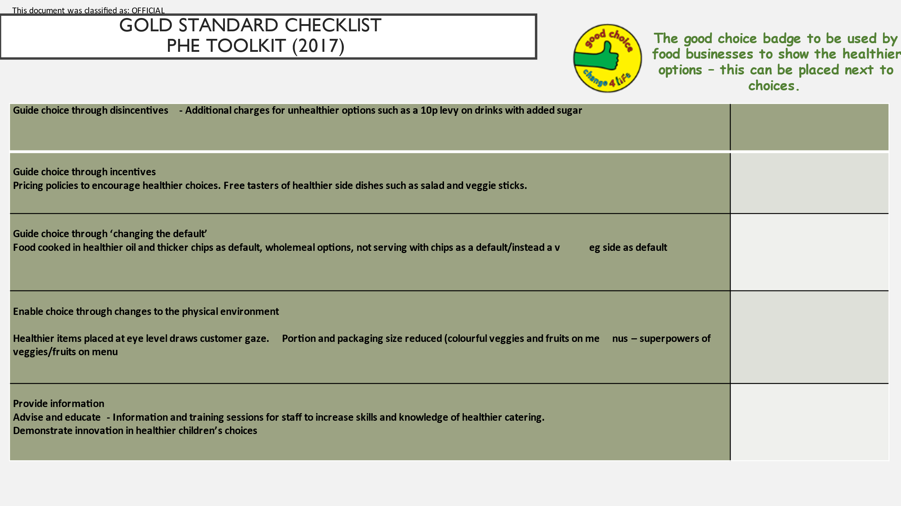
Using framing for public and business comms – example

Did you know that the food eaten ‘out of home’ contributes a high percentage of our overall calorie intake, making it much more challenging to maintain a healthy weight? At least 1 in 5 children eat from food outlets outside the home each week, and these foods are very often much higher in fat, sugar and salt and lower in nutrients, with meal deals popular for our budgets.
In County Durham we want every child and citizen to flourish, and one way we can support a healthy weight, and better health outcomes for everyone is by making it easier to choose healthier foods and drinks when eating outside of the home.
This is why Food Durham partnership has developed healthy catering award scheme for businesses and settings where food is served/consumed outside of the home.
Most settings which serve food to the public are eligible for the awards, including restaurants, pubs, cafes, takeaways, hotels, workplaces, hospitals, schools and early years settings including childminders.

Some examples of how healthier options will be achieved in practice
- Using healthier cooking practices e.g. grilling instead of frying
- Promoting and increasing fruits, vegetables and wholegrains
- Decreasing levels of fat, sugar and salt in food/drink
- Increasing healthier options for children
- Using techniques to encourage children to enjoy and accept healthy options such as fruits and vegetables and healthier drinks on the menus

Why healthy eating matters
Research by The Food Standards Agency indicated that customers would like more healthy choices, and being able to access healthy options ‘out of home’ would influence them to eat healthier.
Obesity is an increasing epidemic in the UK and is suggested to contribute to more than 30,000 deaths a year in England. We know that an improved diet is linked to healthy weight and decreased risks of heart disease, diabetes type 2 and some cancers.
Tooth decay is a concern for our children, and lowering the amount of sugar consumed can support better dental health. As such, it’s more important than ever for 'out of home' food to make it easier for everyone to eat healthy.

Families and business

In County Durham, more than X in 10 of children aged 10-11 years are living with obesity.
Childhood obesity impacts on children’s ability to thrive, and may cause bone and joint problems, poor immunity, breathing issues and poor mental health.
To improve the government obesity strategy (July 2020), outlines the need for a whole community approach to address the local environment, including the high street and settings where we live, work, go to school and play.
In County Durham the healthy weight framework (LINK) upholds a vision to support every child to feel emotionally and physically healthy, by providing opportunities to play and have access to and enjoy healthy foods.
Parents can often feel like they are swimming against a powerful flood of unhealthy foods. A community approach that supports families can work as a lifeboat and help improve children’s health. Shifting towards making healthy choices easier choices will support our families to flourish.
With ‘out of home’ food often contributing to high calorie intakes, food business options can play a part in our children’s health. For businesses who support healthy child outcomes look out for the XXXXX (linked to award scheme – merit badge/DCC support/change fo life good choice etc?)

Data Protection
When you complete your application form you are providing information about your premises, however, some of the information may be classed as personal data, for example, your name, address, and telephone number, if you also reside at that address.
Contact details of your food business may be published in Award materials and on the Council’s website. If you do not wish to have your details published you must tell the Officer dealing with your application.
On receipt of your application you will be contacted by an officer from the Environmental Health Section within one working day to arrange a visit to your premises.

Why the award is good for your business and your customers
If you have a catering business or serve the public achieving a Darlington healthy eating award is good for you and your customers because:
- You can help your customers improve their diet and health by providing healthy choices
- You will receive public recognition for achieving the award, showing you care for the health of your customers
- Your customers will feel valued and it may well increase customer satisfaction as the demand for healthier choices grows
- Companies and retailers who have introduced healthier options have experienced a growth in sales
The award is free and assessments will be carried out by XXXX

